Minutes of the meeting of Cherry Burton Parish Council held at 7.30pm on Tuesday, 7 April 2026 at the Sports Pavillion.

P R E S E N T

Parish Councillors: P Arandle, A Baker, B Dickinson, P Gorton, R Howe, P Langley (in the Chair), J Powell and E Sutcliffe.

Clerk to the Council: A Thorogood

Also in attendance: Ward Cllr D Stewart and Police Constable J Scotter.

 | APOLOGIES
 | That apologies from absence were received from Cllr S Peirson.
 | DECLARATION OF INTERESTS
 | RESOLVED: | - that Cllr Baker declared an interest in the Tennis Club;  - that Cllr Gorton declared an interest in the Allotments;  - that Cllrs Arandle and Langley declared an interest in the Village Show Committee.
 | PUBLIC PARTICIPATION SESSION
PC Scotter attended. It was discussed that traffic was an ongoing issue for the village. An Automatic Number Plate Recognition (ANPR) camera had been approved and Speed Indicator Devices (SIDs) and White Gates were being applied for. A roundabout had been considered for the Bishop Burton Road/Eton Road junction, however this had not received community support. It was noted by PC Scotter that speeding hotspots were the exits from the village, particularly during commuting times, and speed enforcement would be undertaken. PC Scotter confirmed that speed checks and stops had been undertaken recently. It was noted that perception of vehicle speed was increased on the narrow lanes. It was discussed that Community Speed Watch was completed two -three times monthly at varying times of day.
Parking on footpaths during school drop off and collection times was an issue for the village. PC Scotter would produce a letter for the school to send out to parents. Photographs of unlawful parking would be taken by PC Scotter and fines would be issued. The blocking of paths was mainly an issue on Canada Drive, Elm Drive and The Meadows. It was recommended by PC Scotter that the removal of the yellow line outside of the village shop be considered. It was believed that this would help alleviate unlawful school parking. The Parish Council would discuss these issues with the Cherry Burton Primary School.

A Cllr queried the legality of cars parking up with the engine running. Idling was confirmed to be unlawful.
It was discussed that a reduction of road speed limit required raising with the Local Authority (LA). A process of consultation would be required.

The Parish Council was liaising with Cherry Burton Voice, and public consultation would be undertaken.
 | RESOLVED: | - that speed enforcement be undertaken;  - that Community Speedwatch be undertaken at commuting times;  - that parking issues be discussed with Cherry Burton primary School;  - that the reduction of road speed limit be raised with the Local Authority.
NOTE: Police Constable J Scotter left the meeting at this point.
 | MINUTES
 | RESOLVED: that the minutes of the meeting held on 3 March 2026 be confirmed and signed by the Chair.
 | ACTIONS
 | RESOLVED: that all actions had been completed.
 | EAST RIDING COUNTY COUNCIL MATTERS
 | The objections relating to the Canada Drive/ Hudson Way footpath had been withdrawn and the process would move forward to the next stage. Thanks were expressed to Ward Cllr Stewart for the hard work undertaken with this matter.
 | RESOLVED: that thanks be given to Ward Cllr Stewart.
NOTE: Ward Councillor D Stewart left the meeting at this point.
 | CORRESPONDENCE RECEIVED
Bench Request
Parish Councillors would meet with the requestee to discuss the siting of a bench. The Parish Council would endeavour to approve memorial benches where possible. The planting of a Cherry tree was also approved.
 | RESOLVED: that Cllrs meet with the requestee to discuss the siting of a bench and a Cherry tree.
 | Automatic Number Plate Recognition Camera (ANPR)
 | Funding for an ANPR camera had been granted by the Police and Crime Commissioner.
 | RESOLVED: that funding had been granted.
FINANCE

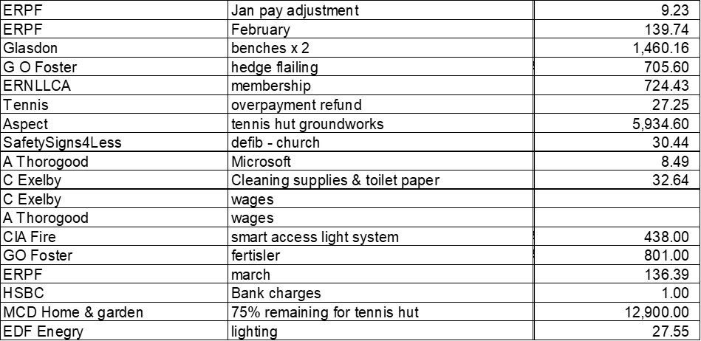
 | RESOLVED: | that the payments be approved;  that the summary so far be approved;  that the budget monitoring be approved.
 | VILLAGE INFRASTRUCTURE
Planning
i. 26/30140/CONDET – no comments;
ii. 26/00806/TPO – no comments.

Sports Field
A Sports Field Management Committee (SFMC) meeting would be held on 14 April 2026.
The gates were scheduled to be repaired. It was discussed that a pedestrian gate be erected with a ‘No Dogs’ sign.

A request had been made to be able to leave flowers on memorial benches. This was unanimously approved by the Parish Council, but it was requested that they be tidied regularly.

Pond
An environmental survey of the pond had been undertaken and would be shared once completed.

Allotments

- Polytunnel Request
The Parish Council discussed that moving to metric would better fit the measurements of manufactured sheds, greenhouses and polytunnels. A such, the allotment rules for sheds and greenhouses would be amended to state 3x3 metre. Subsequently, the polytunnel request was approved.

- Parking Request
It was noted that Highways land was used by allotment holders to park directly outside the Bishop Burton Road allotments and as such the Parish Council had no ownership of this land. It was felt that adequate parking was available in the Sports Field car park.
 | RESOLVED: | - that a Sports Field Management Committee meeting would be held on 14 April 2026;  - that the allotment rules for sheds and greenhouse be amended to state 3x3 metre;  - that the polytunnel request be approved.
 | COMMUNITY ISSUES
Bus Service
A response had been received from the office of the Mayor of East Riding of Yorkshire. There had been no acceptance or decline of the invite to attend a Parish Council meeting. It had been stated that the Strategic Bus Partnership would be in contact with Parish Councils. A request to regulate the cost of bus travel across the East Riding had been raised, as had the lack of public transport before 10.00 am. The Parish Council would continue to correspond with the Mayor and would look to work with Cherry Burton Voice.
Bat Monitoring
A request had been made to undertake Bat Monitoring. Formal details were requested and this would be discussed at the May 2026 meeting.

The Trod hedge had not been cut; a reminder would be sent to the Local Authority (LA) regarding enforcing the owner to cut the hedge.
 | RESOLVED: that a reminder be sent to the Local Authority regarding enforcing the owner to cut the hedge
 | NEWSLETTER
 | RESOLVED: that the Newsletter update be received.
 | REVIEW OF ACTIONS
 | RESOLVED: that the Review of Actions be confirmed and circulated to Councillors following the meeting.
 | FUTURE MEETINGS
 | RESOLVED: | - that the SFMC meeting be held Tuesday, 14 April 2026 at 7.30pm;  - that the Annual Parish Meeting be held Tuesday, 5 May 2026 at 7.30pm.
_____________________________________
Chair’s Signature – 5 May 2026.

