Minutes of the meeting of Cherry Burton Parish Council held at 8.10pm on Tuesday, 5 May 2026 at the Sports Pavillion.

P R E S E N T

Parish Councillors: P Arandle, A Baker, B Dickinson, P Gorton, R Howe, P Langley (in the Chair), S Peirson, J Powell and E Sutcliffe.

Clerk to the Council: A Thorogood

 | APOLOGIES
 | All Councillors were in attendance.
 | DECLARATION OF INTERESTS
 | RESOLVED: | - that Cllr Baker declared an interest in the Tennis Club;  - that Cllr Gorton declared an interest in the Allotments;  - that Cllrs Arandle and Langley declared an interest in the Village Show Committee.
 | PUBLIC PARTICIPATION SESSION
 | RESOLVED: | that no members of the public had attended.
 | MINUTES
 | RESOLVED: that the minutes of the meeting held on 7 April 2026 be confirmed and signed by the Chair.
 | ACTIONS
 | RESOLVED: that all actions had been completed.
 | EAST RIDING COUNTY COUNCIL MATTERS
 | RESOLVED: that there were no matters to discuss.
 | CORRESPONDENCE RECEIVED
Scouts
A request had been received for funding. The Parish Council would welcome an application form. It was queried whether other Parish Councils or organisations had been approached. Information would be requested as to what the funding would be used for. The Parish Council would also direct the Scouts to available funding from other sources.

Community Safety Funding Guide
 | Funding was available for improving community safety. The Parish Council would give further consideration to CCTV and security lighting around the Pavillion and Tennis Courts. It was discussed whether the installation of CCTV was proportionate to the number of issues arising.
 | RESOLVED: | - that the Scouts be requested to complete a funding application;  - that the Community Safety Funding grant be applied for.
 | AUTOMATIC NUMBER PLATE RECOGNITION CAMERA (ANPR)/SPEED INDICATOR DEVICES (SIDS)
 | ANPR signage costs had been included in the grant and an application was being made to have these sighted on the White Gates, should the gates be approved. The Parish Council was awaiting the grant for signing.
 | RESOLVED:
FINANCE

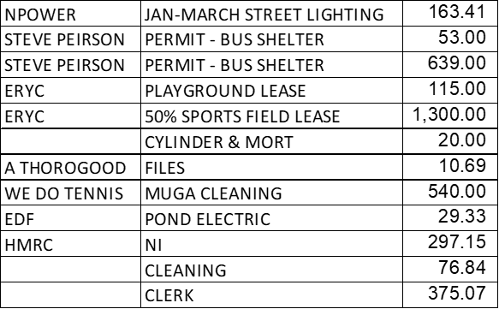
 | RESOLVED: that the payments be approved.
 | VILLAGE INFRASTRUCTURE
Planning
- 26/00908/VAR – there was concern this may spoil the look of the building, but it was acknowledged that this could not be seen from the roadside, no formal comment required;
- 26/00809/PLF – no comment;

Sports Field
- MUGA – to be carried forward to the June 2026 Parish Council meeting;
- Bats – the survey would be carried out 10 June 2026. A request had been made to install a bat camera at a cost of £135. The Parish Council agreed to fund this.
An external water fountain was discussed, however there were health and safety concerns. It was noted that sports clubs had access to the Pavillion for fresh water.

Pond
- Survey – Cllrs accepted the quote and agreed to survey the pond.

Allotments
- National Allotment Survey – Cllr Peirson agreed to complete the National Allotment Survey;

Water leaks had been identified on Highgate and Bishop Burton allotments which required repair.

 | RESOLVED: | - that the MUGA be discussed at the June 2026 Parish council meeting;  - that a Bat camera be purchased at a cost of £135;  - that the pond be surveyed;  - that Cllr Peirson agreed to complete the National Allotment Survey;  - that allotment water leaks be repaired.
 | COMMUNITY ISSUES
Bus Service
There had been no further engagement from the Mayor’s office. This would be escalated to the supervising Minister.

 | RESOLVED: that the Bus Service concerns be escalated to the supervising Minister.
 | SFMC
The Tennis Courts had been cleaned, funded by the Tennis Club.
The increasing cost of maintaining the Sportsfield and Pavillion was discussed and it was agreed to raise the annual rents in the following manner:
- Junior Football Club – 10 percent increase;
- Ladies Football Club – 10 percent increase plus an additional £50.00;
- Cricket Club - £50.00 increase;
- Tennis Club – 10 percent increase;
- Scouts and Guides – 5 percent increase.
 | RESOLVED: that the annual rents be invoiced.
 | NEWSLETTER
 | RESOLVED: that the Newsletter update be received.
 | REVIEW OF ACTIONS
 | RESOLVED: that the Review of Actions be confirmed and circulated to Councillors following the meeting.
 | FUTURE MEETINGS
 | RESOLVED: that the next be held 2 June 2026 at 7.30pm.
_____________________________________
Chair’s Signature – 2 June 2026.

