MINUTES of the Meeting of Cherry Burton Parish Council held on Tuesday, 7 July 2026 at 7.30pm.
_________________________________________________________________________

P R E S E N T:-

Cllr Peter Langley (in the Chair)

Parish Councillors: P Arandle, A Baker, B Dickinson, P Gorton, R Howe, S Peirson, J Powell and E Sutcliffe.

Also in attendance: Ward Cllr Stewart

Clerk – Ashley Thorogood

 |  | APOLOGIES
 |  | An apology for absence was received and accepted from Cllr A Baker.
 |  | DECLARATION OF INTERESTS
 |  | RESOLVED: | - that Cllr Baker declared an interest in the Tennis Club;  - that Cllr Gorton and Cllr Peirson declared an interest in the Allotments;  - that Cllrs Arandle and Langley declared an interest in the Village Show Committee.
 |  | MINUTES
 |  | RESOLVED: that the minutes of the meeting held on 2 June 2026 be confirmed and signed by the Chair.
 |  | UPDATE OF ACTIONS
 |  | RESOLVED: | - that the registry of land on Canada Drive be carried forward;  - that Dog Stencilling be carried forward.
 |  | EAST RIDING OF YORKSHIRE COUNTY COUNCIL MATTERS
Ward Cllr Stewart had actively pursued progress with the Canada Drive/Hudson Way footpath; however, despite much chasing no return correspondence had been received from the local authority.

Cllrs were encouraged to give time and thought to planning applications as a merger was occurring to create one planning department for the East Riding.

It was raised that the cycle path from Cherry Burton to Beverley required cutting back to enable access, this also applied to the Eton Road trod. The Ward Cllr would rise these with the local authority.

The bund on Canada Drive had not been maintained to appropriate standards by the local authority, with an area of the bank uncut. It was requested that this be queried by the Ward Cllr.

A hedge on Highgate was of an extreme height and causing the footpath to be impassable. Cllrs would report this to Streetscene individually.

There was no update available regarding the A1079 lanes opening.
 |  | RESOLVED: |  | - that the East Riding of Yorkshire County Council Matters be received;  - that the Ward Cllr continue to progress the Canada Drive/Hudson Way footpath;  - that maintenance of the Cherry Burton to Beverley cycle path, the Eton Road trod and the bank on Canada Drive be raised by the Ward Cllr with the local authority;  - that the Clerk would follow up contact with Streetscene regarding Eton Road trod.
 |  | CORRESPONDENCE
Grassed area Canada Drive
It was raised that should the Parish Council wish to create wildlife areas, in future public consultation should be undertaken. The area in question would be put forward to be included in the local authority grass cutting, with care to be taken during spring for the bulbs.

Cutting of the flood barrier Canada Drive
The Ward Cllr would be raising this matter with the local authority.

Dogger Bank consultation
Received.

English Devolution and Community Empowerment Act
Received.

Biodiversity
The Parish Council had adopted a Biodiversity Policy and funded a Habitat and Species Identification training course for a Cllr and Parishioner, whose contributions were greatly appreciated. The Parish Council was making consistent progress forwards with biodiversity. The Biodiversity Plan was an evolving document and would be audited in February 2027.
 |  | RESOLVED: | - that the local authority be requested to cut the grassed area on Canada Drive;  - that the Ward Cllr would raise the cutting of the flood barrier with the local authority;  - that the Parish Council continue making progress forwards with biodiversity.
 |  | ANPR/SIDS/WHITE GATES
Applications had been submitted to the Local Authority for SIDS and White Gates.
The ANPR camera had been delivered and was hoped to be installed this week.
 |  | RESOLVED: that the ANPR/SIDS/White Gates update be received.
 |  | FINANCE
Accounts for payment

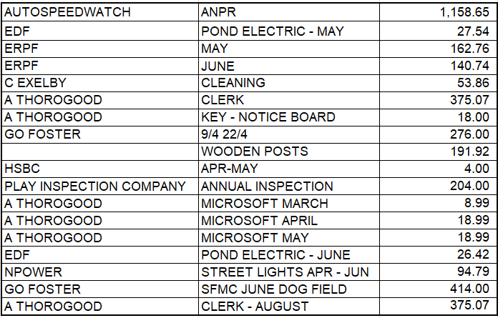

Accounts and budget for approval
The accounts were scrutinised and approved.
 |  | RESOLVED: that the Finance be approved.
 |  | VILLAGE INFRASTRUCTURE
Planning
i.26/01437/TPO – no comment;
ii. 26/01432/TPO -no comment;
iii.26/00712/PLF - received;
iv.26/01452/TDD – no comment;
v. 26/01509/TDD – no comment;

Play Park
Commuted Sums had been allocated for the Play Park. New equipment and surfacing had been installed earlier in the year with grants funding; however, it was noted that the surfacing near the gate way still required attention and that an area of concrete had been left from the removal of the bin. The play inspection report would be considered and a decision made.
It was discussed that Scouts and Guides, Lifestyle or Friends of the School may wish to undertake a check of the playpark on a regular basis.

Pond
Advise had been sought from neighbouring parishes regarding pond maintenance and dredging. Formal advise would be sought from the Environment Agency. Cllrs would look for grant funding to support this project.
It was raised that there were approximately 200 goldfish within the pond.

A land survey was to be undertaken of the pond boundary.

Pavillion
The immersion water heater, in the loft, for the kitchen and the ladies’ toilets was not working. A plumber would be contracted.

Allotments
An inspection was to be carried out of the allotments. The leaks were yet to be addressed.

Dog Walking Field
Wild roses from the dog walking field had been potted to protect them from mowing and would be re-planted in the hedge rows.

Storage
It was suggested that the commuted sums would be better allocated to storage. There was a need to provide storage for the Village Show and the Scouts and Guides.
A working party would meet to consider viable storage options on Tuesday, 4 August 2026.

Nature Trail
Cllr Peirson would create a wooden gate for the Nature Trail. New gate posts were required. Cllrs agreed to purchase two gate posts and concrete.

Quotes had been sought for an Ash Dieback survey. For approximately £600.00 - £750.00 the local authority arborist would assess all 300 ash trees and create a long-term care and maintenance plan. No other quotes had been received. Branches were falling down within the Nature Trail. Consideration was given to using a tree surgeon annually, however Cllrs agreed to go ahead with an arborist Ash Dieback survey. An additional quote would be sought.

Future Projects
A consultation had been previously held, with ideas such as storage put forward, as well as play equipment for older children on the Sports Field. It was noted that Proludic had previously submitted potential play park plans, these would be reviewed for suitability. A Pétanque pit was suggested.
A bin next to the bus shelter was suggested, however it was noted that there was a bin on the opposite side of the road.
 |  | RESOLVED: |  |  | - that Cllrs review the play park inspection;  - that Friends of the School be requested to undertake play park inspections and feedback to the Parish Council;  - that a land survey of the pond boundary be undertaken;  - that the Environment Agency be approached for advice regarding the pond;  - that the Pavillion immersion heater be repaired;  - an allotment inspection be undertaken;  - that the wild roses be re-planted in the hedgerows;  - that a working party meet Tuesday, 4 August 2026 to consider viable storage options;  - that Cllrs agreed to the purchase of two gate posts for the Nature Trail;  - that quotes be sought and an arborist Ash Die Back survey be undertaken;  - review Proludic play park plans for suitability.
 |  | COMMUNITY ISSUES
Bus Service
A response had been received and there was a willingness to meet with the Parish Council. Community feedback and support was now required to move this forward. It was hoped that some of the X46 buses, which ran every 30 minutes, could divert through Cherry Burton. Engagement with parishioners would be undertaken. Cllr Peirson would undertake a letter drop and a Facebook post would be created.

Power Cut
A letter of complaint would be sent to Northern Power regarding the power cut.
 |  | RESOLVED: | - that a letter drop to gather public feedback regarding the bus service be undertaken;  - that a Facebook post be created to gather public feedback regarding the bus service;  - that a letter of complaint regarding the power cut be sent to Northern Power.
 |  | SFMC
Electricity Contract
Cllrs reviewed the electricity contract and agreed that the Eon two year fixed deal was the best option.

Accounts
The SFMC Barclays account was in the process of being closed and transferred to the Responsible Financial Officer, who would operate and audit these funds separately to Parish Council funds, through HSBC banking.
 |  | RESOLVED: that the Eon two year fixed electricity contract be signed.
 |  | NEWSLETTER
 |  | RESOLVED: that the Newsletter be shared on Facebook.
 |  | REVIEW OF ACTIONS
 |  | RESOLVED: that the Review of Actions be confirmed and circulated to governors following the meeting.
 |  | FUTURE MEETINGS
 |  | RESOLVED: that future meetings be held at 7.30pm on the following dates:
Parish Council Meeting
Tuesday, 8 September 2026;
Tuesday, 6 October 2026;
Tuesday, 3 November 2026;
Tuesday, 1 December 2026;
Tuesday, 5 January 2027;
Tuesday, 2 February 2027;
Tuesday, 2 March 2027;
Tuesday, 6 April 2027,
Tuesday, 4 May 2027;
Tuesday, 8 June 2027;
Tuesday, 6 July 2027.

Annual General Meeting
Tuesday, 6 April 2026.

Sports Field Management Committee
Tuesday, 8 September 2026;
Tuesday, 1 December 2026;
Tuesday, 2 March 2027.
_____________________________________
Chair’s Signature – 8 September 2026.

