MINUTES of the Meeting of Cherry Burton Parish Council held on Tuesday, 6 October 2026 at 7.30pm.
_________________________________________________________________________

P R E S E N T:-

Cllr Peter Langley (in the Chair)

Parish Councillors: A Baker, B Dickinson, P Gorton, R Howe, S Peirson, J Powell and E Sutcliffe.

Clerk – Ashley Thorogood

 | APOLOGIES
 | An apology for absence was received from Cllr P Arandle.
 | DECLARATION OF INTERESTS
 | RESOLVED: | - that Cllr Baker declared an interest in the Tennis Club;  - that Cllr Gorton declared an interest in the Allotments.
 | MINUTES
 | RESOLVED: that the minutes of the meeting held on 8 September 2026 be confirmed and signed by the Chair.
 | UPDATE OF ACTIONS
Minute 9/26/51 – East Riding of Yorkshire County Council Matters
Debbie Wesselby, LA Senior Legal Officer, had confirmed that ownership of the 8m strip of land by the Parish Council was not required as a public footpath order could be instructed across it.

Minute 9/26/54 - Finance
It was confirmed that all testing would be facilitated under the SLA and an annual report provided when requested.

Minute 9/26/55 – Village Infrastructure
A new first aid kit was purchased for the Pavilion in January 2026, all items in this had a minimum one-year shelf life.

Minute 9/26/58 – CPR and Defib Policy
Defibrillator training had been arranged for Friday, 27 November 2026 at the Village Hall. Three sessions could be supported with 12 persons per sessions. This would be offered to persons of sites that held a Parish Council defibrillator in the first instance and then opened to parishioners who did not have access to this training through other means.
The defibrillators were registered with and operated through The Circuit - National Defibrillator Network, and their guidance was to undertake monthly checks. The Parish Council have a formal checking system with the details and dates of checks uploaded onto The Circuit website - which then informed the emergency services the defibrillators were functioning and useable. The Sportsfield and The Bay Horse defibrillators were purchased in 2015 through a HEY Smile Foundation grant as part of a CADEY scheme. This funding was no longer available. The High Gardham defibrillator was four years old and purchased through a Hull Corn and Feed Trade Association grant. This defibrillator had been upgraded in September 2026 to include a ‘Stop the Bleed’ kit. The St Michael’s and All Angels defibrillator was not yet 12 months old. Whilst defibrillators had a shelf life of five years for the battery, these were replaceable and had been kept up to date. The defibrillators had an eight-year warranty; they did not have an expiry date and guidance suggested that with regular checking and replacement of batteries and pads they would continue to be fit for use. It was suggested that funding be allocated in future years to begin defibrillator replacement.

Minute 9/26/56 – Community Issues
A discussion was held regarding the Bus Service Response letters and GDPR. It was decided that this information in its full format could be shared with the Mayor’s Office.

Minute 9/26/52– Correspondence
The Relief in Need Charity had been investigated. There was a plaque commemorating members of the charity mounted in St Michaels and All Angels Church; however, all members were deceased.

 | RESOLVED: | - that the Street Lighting Service level agreement be approved and signed;  - that a letter of appreciation for the donation of the ‘Stop the Bleed’ kit be sent to Hull Corn and Feed Trade Association;  - that the letter to Npower was still to be completed.
 | EAST RIDING OF YORKSHIRE COUNTY COUNCIL MATTERS
 | RESOLVED: that no matters be discussed.
 | CORRESPONDENCE
ANPR cameras
The Clerk had responded.

Hedges on Etton Road
Streetscene would inspect the hedges on Etton Road.

Driffield Foodbank
The Parish Council supported foodbanks and would enlist the Ward Councillors to raise this at the Scrutiny Committee.

Mobile Phone Signal
The Parish Council agreed that the mobile phone signal within the East Riding of Yorkshire was problematic and would share this with parishioners on Facebook.

Rough Sleeper Survey
Cllrs would undertake the survey.
 | RESOLVED: | - that Streetscene be requested to assess the hedges on Etton Road;  - that a letter of support be sent to Driffield Foodbank;  - that the Ward Councillor be requested to raise Driffield Foodbank at the Scrutiny Committee;  - that the mobile phone signal information be shared on the Parish Council Facebook page;  - that the Rough Sleeper Survey be undertaken.
 | SIDS
The placement of Speed Indicators Devices (SIDs) had been approved by the Local Authority, either side of Chery Burton Primary School. Funding was not available for SIDS and as such Cllrs would reassess the quotes.
The ANPR cameras were functioning, and it was discussed that this should be publicised within the community. The Police Service were able to access and use this information to address offenders. There were issues with the ANPR camera signage being removed and these required replacing.
 | RESOLVED: | - that the SIDS quotes be assessed;  - that four ANPR camera metal signs be ordered at a cost of £95.96.
 | FINANCE
Invoices for payment

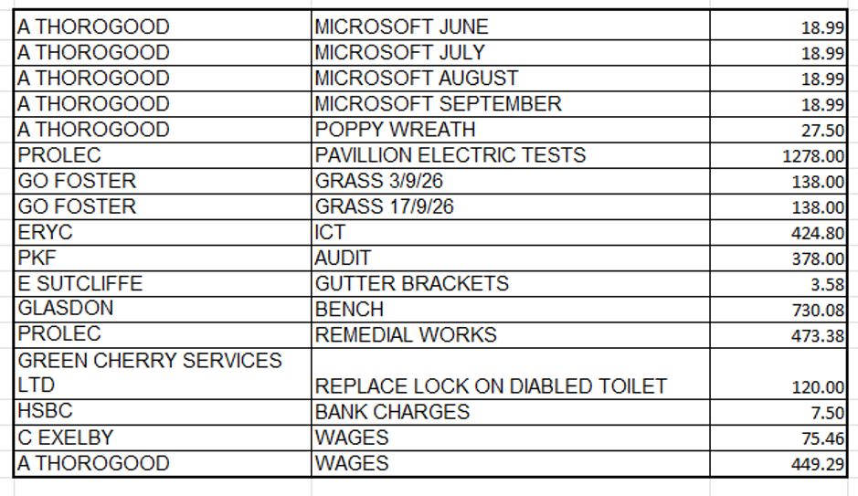

 | RESOLVED: | - that the invoices for payment be approved;  - that the monthly accounts be approved;  - that a donation of £25.00 be sent to the Royal Legion.
 | VILLAGE INFRASTRUCTURE
Play Park
The Play Park signage required updating to reflect the new Parish Clerk email address.

The Parish Council had received notification that a child had sustained an injury, including broken fingers, while using the Parish Council playpark. The incident was reported promptly to the Council, and the Chair had completed the accident form in accordance with the Council’s accident‑reporting procedure. Broken fingers were not classified as a RIDDOR‑reportable injury, and therefore no RIDDOR submission was required. The Clerk confirmed that the incident has been logged in the Council’s accident register, and the play equipment involved had been inspected to ensure it remained safe for public use. No defects were identified; however, the equipment was removed from use until Proludic, the play park installation company, could attend to undertake assessment of the equipment. An annual inspection of the playpark had been undertaken by a certified company.

Pond
The LA had raised concerns regarding the diversion of buses and HGVs around Canada Drive, whilst the Christmas Light Switch On event was held. Cllrs had been in touch with the bus company to request postponement of the 4.50pm bus service.

The yellow irises would be cut back.

Storage
A meeting had been held and recommendations and information was awaited.
 | RESOLVED: that.
 | RESOLVED: | - that Proludic would attend to undertake a play park inspection;  - that the yellow irises be cut back around the pond.
 | COMMUNITY ISSUES
Bus service
Bus Service Responses would be shared with the Mayor’s Office. It was raised that Bishop Burton had a half hourly bus service for a significantly small population. The Parish Council would petition for an hourly service.

Cllrs would be attending the East Riding of Yorkshire Enhanced Bus Partnership Forum on 4 November 2026.

Road Closure
 | To be shared on Facebook. A letter would be sent to Powergrid asking for them to rectify the ground where works had been undertaken.
 | RESOLVED: | - that the Bus Survey responses be shared with the Mayor’s office;  - that Cllrs attend the ERYC Enhanced Bus Partnership Forum on 4 November 2026;
 | NEWSLETTER
 | RESOLVED: that no update be received,
 | POLICIES
RESOLVED: that the following policies were reviewed and adopted:

- Social Media Policy;
- Health and Safety Policy.
 | REVIEW OF ACTIONS
 | RESOLVED: that the Review of Actions be confirmed and circulated to governors following the meeting.
 | FUTURE MEETINGS
 | RESOLVED: that future meetings be held at 7.30pm on the following dates:
Parish Council Meeting
Tuesday, 3 November 2026;
Tuesday, 1 December 2026;
Tuesday, 5 January 2027;
Tuesday, 2 February 2027;
Tuesday, 2 March 2027;
Tuesday, 6 April 2027.

Annual General Meeting
Tuesday, 6 April 2026.

Sports Field Management Committee
Tuesday, 8 September 2026;
Tuesday, 1 December 2026;
Tuesday, 2 March 2027.
_____________________________________
Chair’s Signature – 3 November 2026

